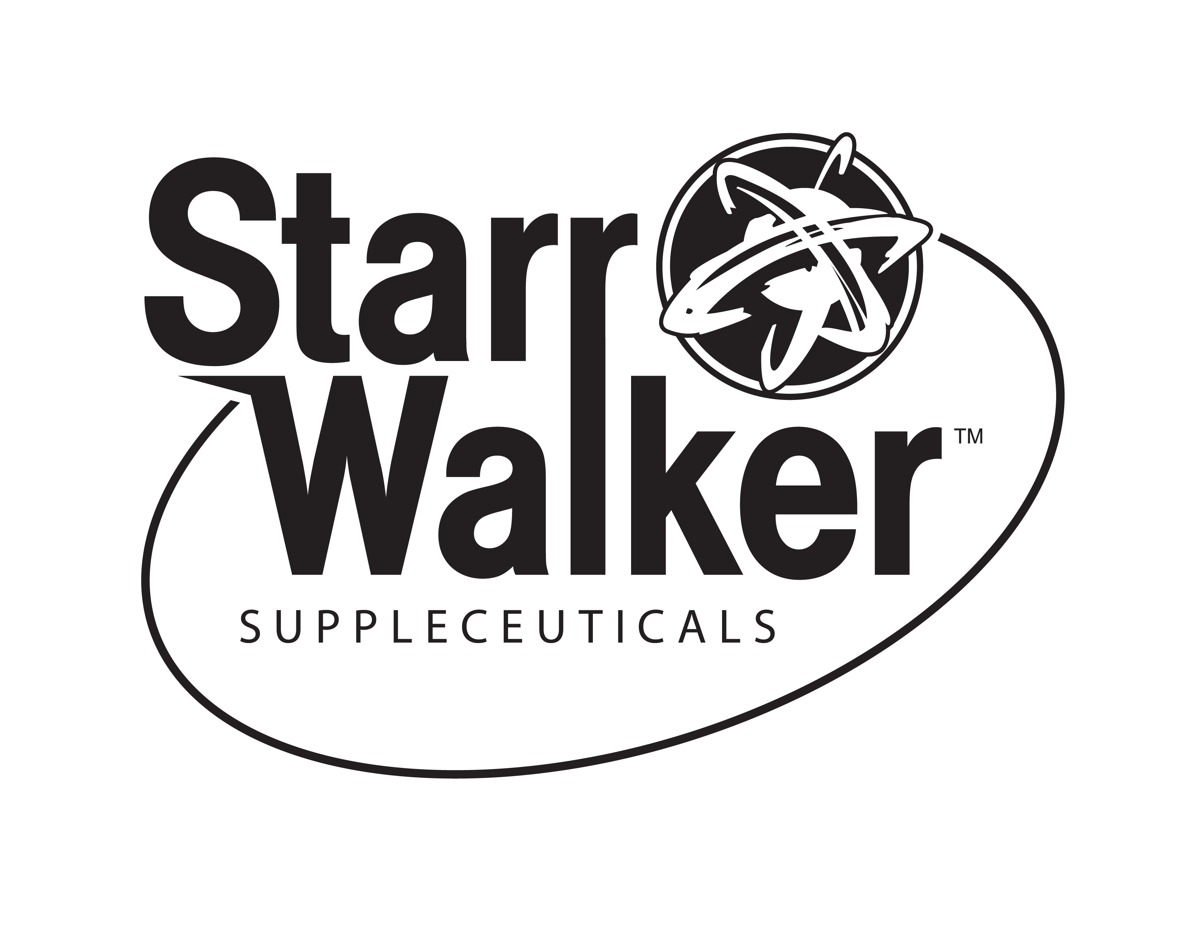
Winter Immune Builder

You need to make sure you are getting all the vital nutrients to protect your body during the winter months. With Starr Walker’s Complete Daily Spectrum you will get the added benefits of 3 main supplements:
Vitamin D3 5000– Vitamin D fights infections, including colds and the flu, as it regulates the expression of genes that influence your immune system to attack and destroy bacteria and viruses. Vitamin D3 has also been found to be beneficial in cardiovascular disease, DNA repair and metabolic processes. Each softgel contains 5000 i.u.’s of vitamin D3.
Flora Daily (Probiotic) - Due to the fact that a large % (around 80) of our immune system is located in our digestive tract it is vital that you keep your digestive tract healthy. Probiotics are the good bacteria that line your digestive tract and support your body’s ability to absorb nutrients and fight infection. Flora Daily is a four-strained probiotic that provides you with 30 billion CFU’s of beneficial bacteria.
EPA/DHA 967 - This fish oil provides 515 mg of EPA and 385 mg of DHA covered by a certified enteric coating. This enteric coating makes it easy to swallow and enables optimal absorption of EPA/DHA in the small intestine, which is where absorption and assimilation occur. There are so many benefits to taking fish oil – gastrointestinal health, heart health, improves hair & skin, joint pain and many more.
Buy a Complete Daily Spectrum and get 50% off Silver Hydrosol Molentrate. This mineral is great at fighting off viruses, bacteria and molds. This product is safe to take every day and that makes it important, especially during the winter months. Start preparing yourself now and stay healthy this winter!!! Silver Hydrosol Molentrate comes in a liquid form, so add it to water or juice of your choice. Great for children too!!
This offer expires 10.31.16 (limit of 2)
● Add Starr Walker’s Vitamin Perfect for additional support (get 15% off Vitamin Perfect if you add to the above package.
Buy all 3 for $110.64 -- normally $135.85

Call “The 3rd Opinion Inc” to order yours today: 1-800-431-7902
These statements have not been approved by the Food & Drug Administration. These products are not intended to diagnose, treat, cure or prevent any disease.

