Cardio Advantage

(Chocolate or Vanilla flavored)
Serving Size: 2 scoops (52 g) 14 servings per container
Cardio Advantage is a medical food formulated to provide specialized nutritional support within a nutritional management program for dyslipidemia by supplying a combination of phytosterols, bioavailable xanthohumol from hops (XNT ProMatrix™), beneficial macronutrient profile, 5 g of fiber (including prebiotic isomalto-oligosaccharides), antioxidant nutrients (vitamins C and E), and a proprietary pea/rice protein base with added amino acids. As part of a heart healthy eating plan the addition of 1.8 g/day of plant sterols/ stanols has been shown to lead to beneficial changes in LDL cholesterol in individuals with hypercholesterolemia.
Ingredients: Pea protein isolate, isomalto-oligosaccharide, rice protein concentrate, organic cane sugar, high oleic sunflower oil, flaxseed, L-lysine HCl, phytosterols, L-leucine, silica, natural flavors, magnesium citrate, L-valine, guar gum, protein matrix and polyphenols from hops extract, vitamin and mineral blend (zinc gluconate, ascorbic acid, manganese gluconate, d-alpha tocopheryl acetate, copper gluconate, D-biotin, retinyl palmitate, niacinamide, cholecalciferol, d-calcium pantothenate, chromium picolinate, pyridoxine HCl, riboflavin, potassium iodide, thiamin HCl, methylcobalamin, calcium L-5-methyltetrahydrofolate, and selenomethionine), L-isoleucine, dicalcium phosphate, Luo Han Guo fruit (monk fruit) extract, and xanthan gum.
Directions: Blend (for no longer than 15 seconds), shake, or briskly stir about 2 level scoops of UltraMeal Cardio 360° (36 g) into 8 ounces of chilled water twice daily, or as directed by your healthcare practitioner. Consume within 10 minutes of reconstitution.You may also blend with ice and/or your favorite fruit.
THIS IS A MEDICAL FOOD FOR ADULTS TO BE ADMINISTERED UNDER THE SUPERVISION OF A HEALTHCARE PROVIDER. KEEP OUT OF REACH OF CHILDREN. DO NOT ENGAGE IN ANY DIET SUPPLYING LESS THAN 800 CALORIES PER DAY WITHOUT MEDICAL SUPERVISION.
This product is non-GMO and gluten free.
Caution: This medical food has not been studied in children and pregnant or nursing women. If taking medication or other nutritional supplements, consult your healthcare practitioner before use.
Tamper Evident: Do not use if safety seal is missing or broken.
SEE INGREDIENTS LISTED ON BACK
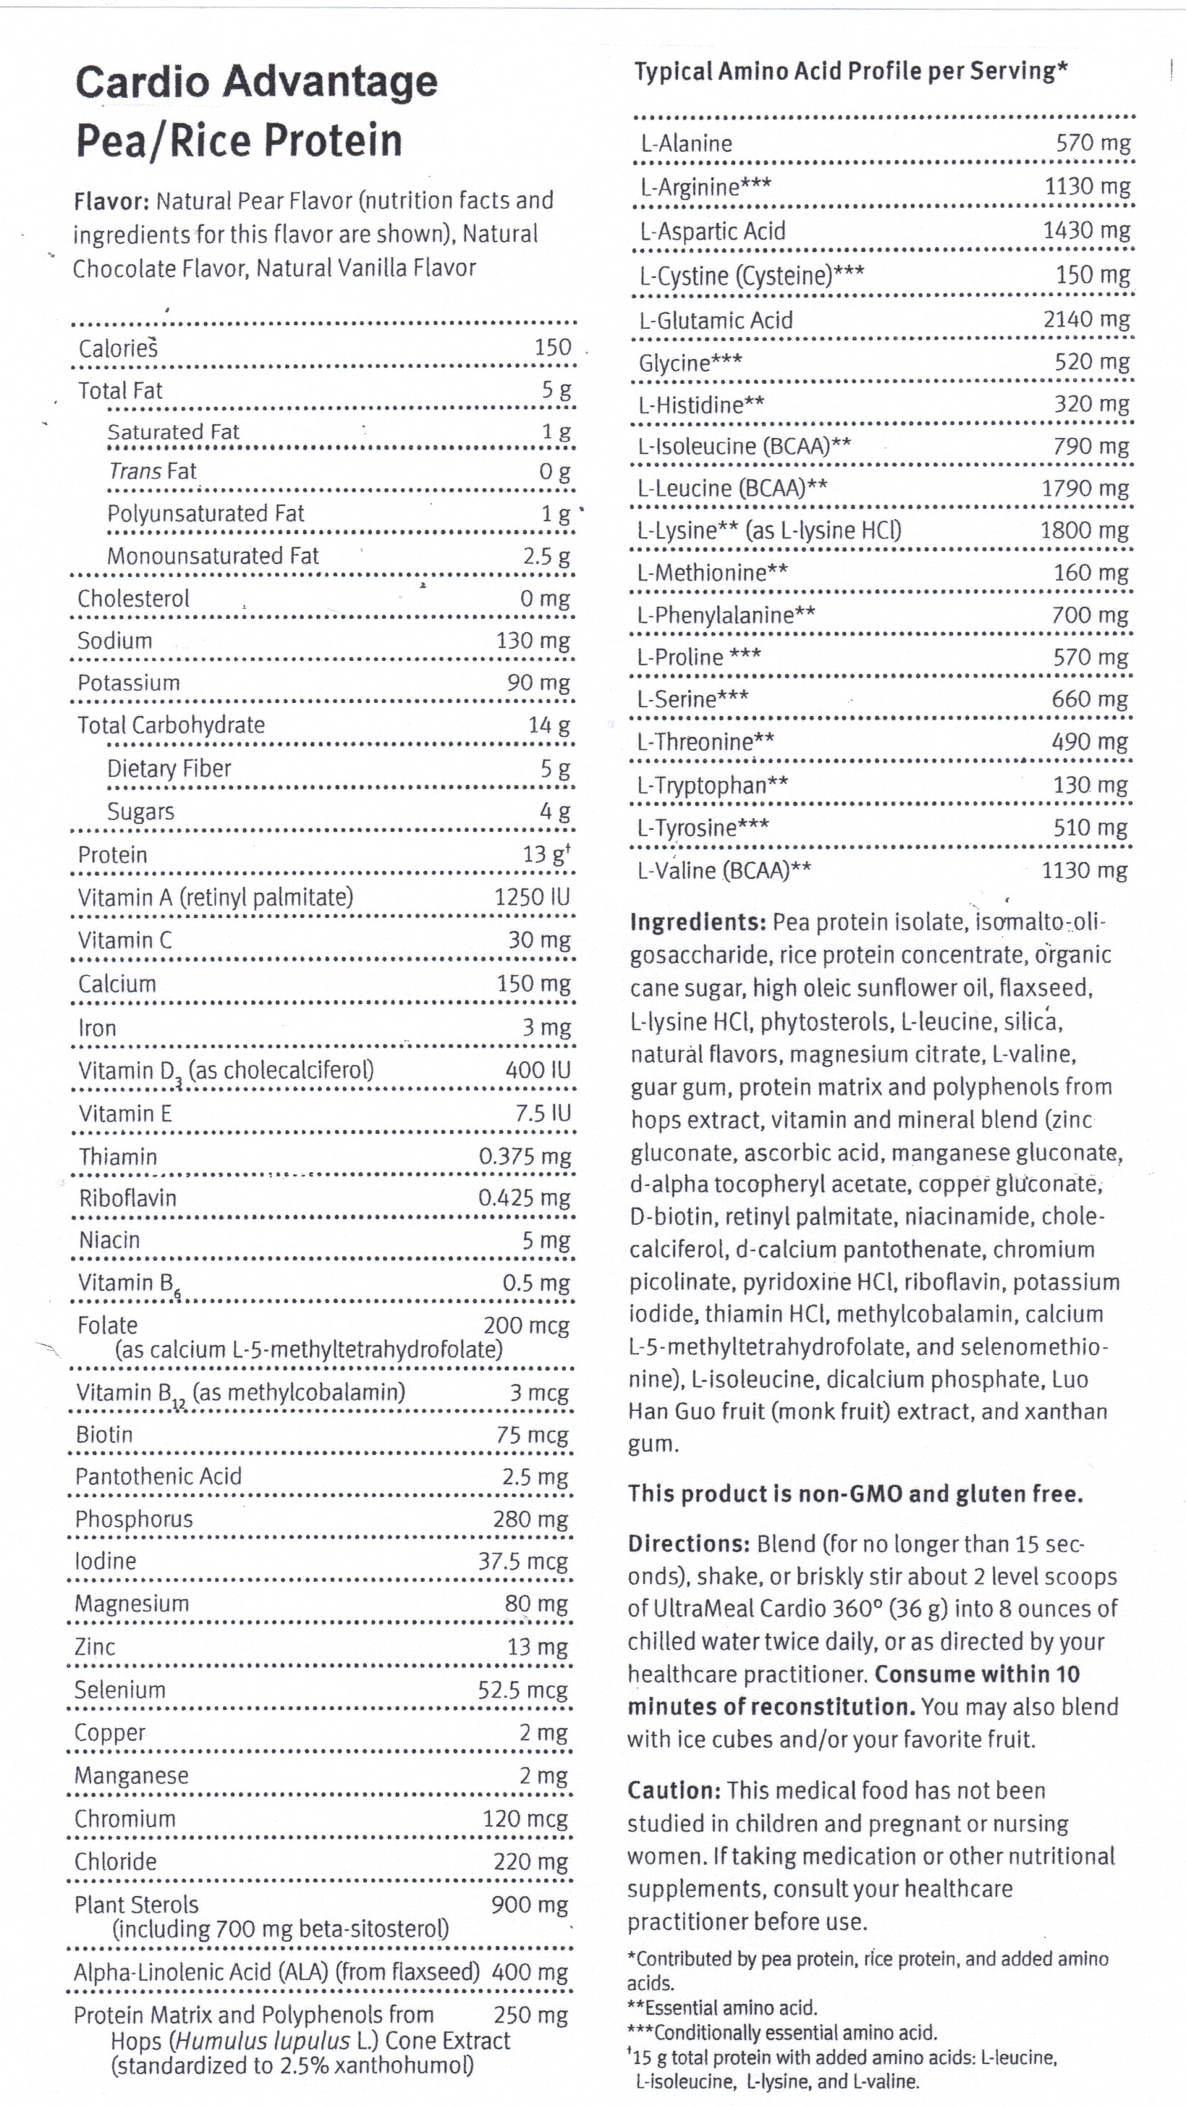

Storage:
Keep tightly closed in a cool, dry place.

The 3rd Opinion Inc. ** 1-800-431-7902 ** www.starrwalker.com
These statements have not been evaluated by the Food & Drug Administration. This product is not intended to diagnose, treat, cure or prevent any disease.

